**UPI Transactions Analysis 2021 and PhonePe Market Assessment**

**Executive Summary**

This report analyses the performance of leading UPI (Unified Payments Interface) banks and payment applications in India during 2021 based on transaction data. It also assesses the market position and strategies of PhonePe, the current market leader in the Indian digital payments space.

**Key Findings:**

1. **UPI Transactions Landscape:**

* PhonePe emerged as the market leader with a 47.4% share of UPI transactions value in 2021, followed by Google Pay (34.3%), Paytm Payments Bank App (9.6%), Amazon Pay (1.3%), and others (see Pie Chart 1).
* The top 5 UPI banks (PhonePe, Google Pay, Paytm Payments Bank App, Cred, and BHIM) collectively accounted for over 90% of the total transaction value (₹41.03 lakh crore) and volume (39.65 billion transactions).

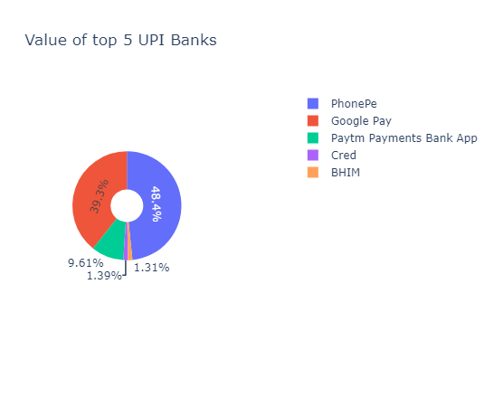

Pie Chart 1: Market Share of Top 5 UPI Banks by Value in 2021

1. **PhonePe's Dominance:**

* PhonePe's "All-in-One QR" strategy, integrating multiple payment options into a single QR code, streamlined merchant payments and contributed to its success.
* Around 46.2% of PhonePe's transactions were merchant payments (see Bar Chart 1), highlighting the efficacy of its QR code solution.
* Strong network effects boosted PhonePe's growth as more merchants adopted its platform, attracting more customers and reinforcing its market dominance.
* PhonePe recorded a staggering 144% year-over-year growth in transaction value (₹19.43 lakh crore) and a 94% increase in transaction volume (18.59 billion) compared to 2020.

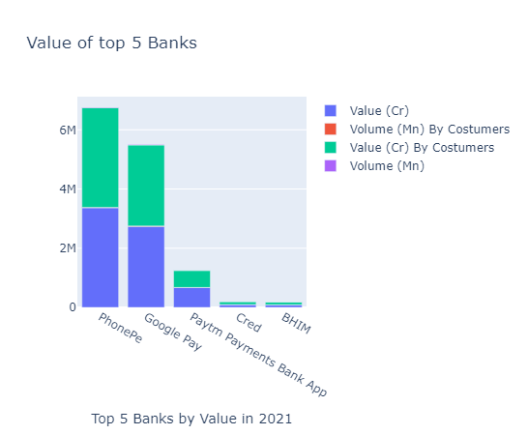

Bar Chart 1: Value of Top 5 Banks by Metrics in 2021

1. **Performance Trends:**

* Overall UPI transaction volumes and values exhibited a steady upward trend throughout 2021 across all leading banks (see Line Chart 1), with a 105% increase in value (₹41.03 lakh crore) and an 88% rise in volume (39.65 billion transactions) compared to 2020.
* PhonePe consistently outperformed its competitors in terms of transaction value and volume, maintaining a substantial lead over the second-ranked Google Pay.
* Google Pay recorded a transaction value of ₹14.05 lakh crore and a volume of 7.83 billion transactions, followed by Paytm Payments Bank App with ₹3.94 lakh crore in value and 5.49 billion transactions.

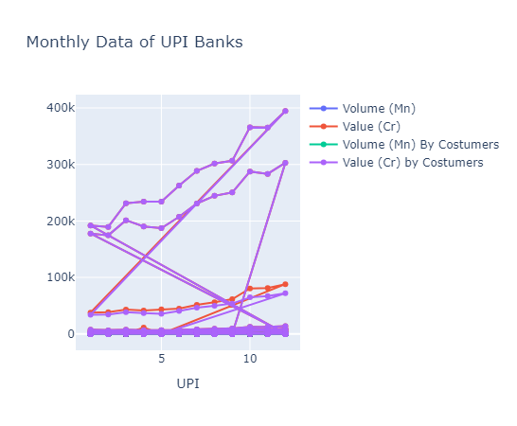

Line Chart 1: Monthly Data of UPI Banks in 2021

**Strategic Recommendations:**

1. Diversify Offerings: PhonePe should consider expanding its services beyond payments to include lending, insurance, and investment products to increase customer engagement and loyalty.
2. Strengthen Merchant Partnerships: Enhancing partnerships with small and medium-sized businesses by offering value-added services like inventory management, marketing support, and loyalty programs can further solidify PhonePe's merchant network.
3. Focus on User Education: Initiatives to educate users about the benefits of digital payments and how to effectively use PhonePe's features can drive adoption among demographics unfamiliar with technology.
4. Leverage Data Analytics: Implementing advanced data analytics techniques to gain deeper insights into customer behaviour, preferences, and market trends can inform targeted marketing strategies and product enhancements.
5. Explore Strategic Collaborations: PhonePe could explore collaborations or partnerships with complementary services, such as e-commerce platforms or ride-sharing apps, to expand its reach and offer integrated solutions to customers.

In India, the digital payments industry is changing quickly. PhonePe can stay ahead of the competition by building on its present market leadership, expanding its product line, and consistently enhancing its user experience.